Working group for Cadastre
Reporters name: |  | Hjörtur Grétarsson
Chairman | Hjörtur Grétarsson
Members  + email addresses | Faroe Islands: Ronnie Thomassen RonnieT@us.fo  Finland: Heikki Lind heikki.lind@maanmittauslaitos.fi , Mauri Asmundela mauri.asmundela@maanmittauslaitos.fi  Iceland: Hjörtur Grétarsson hgr@skra.is , Tryggvi Már Ingvarsson tmi@skra.is , Katrín Holm Hauksdóttir khh@skra.is  Norway: Lars Elsrud Lars.Elsrud@kartverket.no , Anders Braaten Anders.Braaten@kartverket.no  Sweden: Linda Edgren linda.edgren@lm.se, Gunnar Ersbo gunnar.ersbo@lm.se  Denmark: Jess Svendsen jes@gst.dk Uffe Jimenez Ravn-Christensen ufjra@gst.dk Martin Engsig  maeng@gst.dk
Purpose of the group | Networking and knowledge sharing for Nordic Cadaster agencies
Reporting for 2017/2018

Progress compared to last year
- Please inform also how the strategic goals of the Nordic Cooperation Strategy have been implemented
The working group has been active last year. There have been five SKYPE meetings with important issues. The meeting have been informative, new project in each country reviewed and problems that we are faced discussed. Then Nordic strategic goals have been a good reminder to e.g. look into future trends, effectiveness etc.

We had working days in Iceland in 25 – 26 April where the focus was on quality of Cadastral data and maps as well as presentation of important projects in each country.

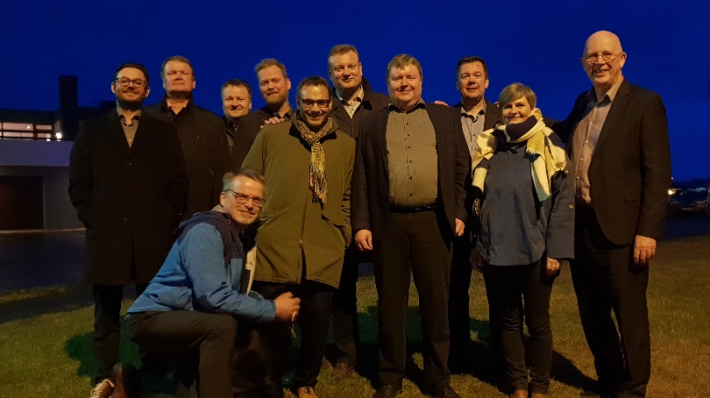

Here we list the activities and discussion in terms of the Nordic Cooperation Strategy.

- Needs of the society – present & future trends:
  - Augmented reality and needed accuracy.
- Position of the NMCA’s and role in future society:
  - The question on where our Cadaster ends and Marin maps appear has been raced.
- Future services and data solutions.
  - We are following Kartverkets project on Cadaster maps in augmented reality in a project called “Border-Go”.
- Effective organizations.
  - We are following changes in changed roles in Finland where Cadaster and Land register is done by the same person now.
  - There is a challenging “Broadband project” in Sweden where faster process is needed.
  - In Denmark, there is an extensive study by COWI on the quality of the Cadasters and suggestions for improvement projects.
- Shared competences.
  - The focus has been on sharing information in our Skype meetings.
- Cooperation in the international arena.
  - We have discussed international cooperation, e.g. FIG work.
  - We are looking for conferences and knowledge on Marine Cadaster
Tasks/ activities for 2018-2020
Deliveries with timeline:

Who is responsible/ chair for the activity and who are involved: Hjörtur Grétarsson is responsible for working group one more year.

What strategic goal will the activity support and how: As can been seen above, the knowledge sharing covers all the goals.

Planned meetings for the next year
Our annual meeting will be in Sweden in 2019.
Coordination with other working groups
No.
Tasks or Consequences for other Nordic WG/Network
We would like to discuss if the “Border Go” project in Norway could be expanded and resources from all the Nordic countries could be joined to make more effect.
Future strategy of the group - 2 years view
Future priorities | Quality. Efficiency. New technology.
Anything else you would like to tell?

